|  |  |
| --- | --- |
| outhern River College | **Year 11 Earth and Environmental Science**  **Task 11: End of Unit test** |

|  |  |  |
| --- | --- | --- |
| **Name:** | **Date** | **Score: /42** |

**Question 1**

Describe the difference between the terms referring to examples

a) Commensalism and Mutualism **(4 marks)**

________________________________________________________________________________________________________________________________________________________________________________________________________________________________________________________________________________________________________________________________________________________________

b) Parasitism and predation **(4 marks)**

________________________________________________________________________________________________________________________________________________________________________________________________________________________________________________________________________________________________________________________________________________________________

**Question 2**

Below is a simplified diagram of the Carbon cycle

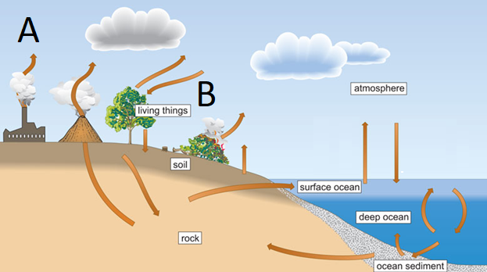

a) Name the processes shown by the letters A and B

A _____________________________ **(2 marks)**

B _____________________________

b) Humans have been impacting the carbon cycle for many years. Describe **2 ways** in which humans have impacted the carbon cycle (**2 marks)**

________________________________________________________________________________________________________________________________________________________________________________________________________________________________________________________________________

c) Describe the impact in increasing carbon emissions has upon our planet. Refer to how this impacts biodiversity (**3 marks)**

________________________________________________________________________________________________________________________________________________________________________________________________________________________________________________________________________________________________________________________________________________________________

d) Governments are now taking measures to reduce the impact of climate change. Discuss **3 ways** we as humans can do to reduce our carbon emissions  **(3 marks)**

________________________________________________________________________________________________________________________________________________________________________________________________________________________________________________________________________________________________________________________________________________________________

**Question 3**

Western Australia’s population is increasing rapidly and this has led scientists to say that the ‘rate at which water is being used in Perth is unsustainable’

a) Explain what this statement means for Perth’s water supply (**2 marks)**

________________________________________________________________________________________________________________________________________________________________________________________________________________________________________________________________________

b) Name three strategies that the government of Western Australia has taken to ensure there is enough water supply for the population (**3 marks)**

________________________________________________________________________________________________________________________________________________________________________________________________________________________________________________________________________

Strict government controls require wastewater to be treated to a level that will minimise the impact on the environment.

c) What are the three stages of wastewater treatment? **(3 marks)**

________________________________________________________________________________________

c) Name the 3 steps involved in **the final stage of** wastewater treatment to ensure that treated water water for Groundwater replenishment meets drinking standards (**3 marks)**

________________________________________________________________________________________________________________________________________________________________________________

**Question 4**

For many decades, farmers in WA were encouraged by the government to clear native vegetation from their land and to plant crops and pasture. More recently, it has been recognized that this policy of land clearing has had disastrous effects on the environment.

a) Describe two ways in which the long term clearing of land for agriculture has affected water resources in Western Australia? (**2 marks)**

________________________________________________________________________________________________________________________________________________________________________________________________________________________________________________________________________

b) What is the name for the process you described above? (**1 mark)**

________________________________________________________________________________________________________________________________________________________________________________

c) Describe how the clearing of land for agriculture has affected biodiversity in Western Australia? (**3 marks)**

________________________________________________________________________________________________________________________________________________________________________________________________________________________________________________________________________________________________________________________________________________________________

d) Farmers discovered that their crops grew better if they applied nitrogen-rich fertilisers to the soil. Describe the effects that this practice could have on the health of nearby waterways (**3 marks)**

________________________________________________________________________________________________________________________________________________________________________________________________________________________________________________________________________________________________________________________________________________________________

e) Describe the measures that farmers can do to lessen these effects (**2 marks)**

________________________________________________________________________________________________________________________________________________________________________________________________________________________________________________________________________

f) What are some measures the local government could do to reduce the prevalence of algal blooms in local waterways (**2 marks)**

________________________________________________________________________________________________________________________________________________________________________________________________________________________________________________________________________________________________________________________________________________________________